SYSTEM/SUBSYSTEM SPECIFICATION

For The

ELDP Situation Awareness/Countermeasure Controller

Prepared By:

BAE Systems Electronics and Integrated Solutions

Nashua, NH 03061-0868

Prepared For:

Engineering Leadership Development Program

1. SCOPE

1.1 Identification
This System/Subsystem Specification (SSS) establishes the performance, design, development, and test requirements for the ELDP Situation Awareness/Countermeasure Controller (SACC) software that is part of the Hit Avoidance Protection (HAP) system.

1.2 HAP Overview
The HAP combines an RF sensor with a RF transmitting countermeasure (CM) and situation awareness/countermeasure control software to provide protection from incoming, RF based threats.

The figure below shows the functional block diagram of the HAP system.

SACC
Sensor
MC/
CM
Non-Volatile
Storage
INU
Ethernet
Figure 1 - HAP Functional Block Diagram

1.2.1 SACC
The SACC is the object of this specification. It includes the core decision making software used to identify threats and allocate countermeasures against those threats.

1.2.2 Sensor
The Sensor reports sensor threat detection data to the SACC as threats are detected. The sensor only reports threats that it determines are incoming and potentially hostile. Because the threat’s emitted wave form data is needed for countering the threat, the sensor provides that data to the SACC.

1.2.3 Countermeasure
Manufactured by the Wayland-Yutani Corporation, the CM is capable of transmitting a jamming signal towards an incoming threat, rendering the threat incapable of tracking its intended target. The CM contains a single, low power emitter that has 360 degrees azimuth coverage. Because of the lower power of the emitter, the CM must be pointed to within 1 degree of the incoming threat. This pointing position must be updated periodically as the vehicle the CM is mounted on moves. Due to its simplistic design, the CM does not have any internal INU, nor does it receive INU data from the mission computer. Therefore, pointing data sent to the CM must account for the heading of the vehicle. The CM is mounted so that a pointing instruction of 0 degrees will point the CM directly out the front of the vehicle.

1.2.4 INU
The Inertial Navigation Unit provides vehicle position data to the SACC.

1.2.5 Non-Volatile Storage
The non-volatile storage unit (NVSU) is used to store system configuration parameters required by any component of the HAP system. This unit is currently a hard drive located in the HAP processor.

System configuration data includes threat specific data. This includes

- Expected threat wave-forms and jam codes associated with the wave-form.
- Threat velocity data (used to determine time-to-go)

The wave forms are compared to wave forms received from the sensor to determine the threat type and the jam code to apply to the threat.

1.2.6 Mission Computer
The Mission Computer (MC), supplied by the Wayland-Yutani Corporation, can command the SACC and receives threat update information from the SACC. It is integrated with the CM and uses the same IP address and port number as the CM.

1.3 SACC Functional Flow
The UML activity diagram below shows the functional flow of the HAP system.

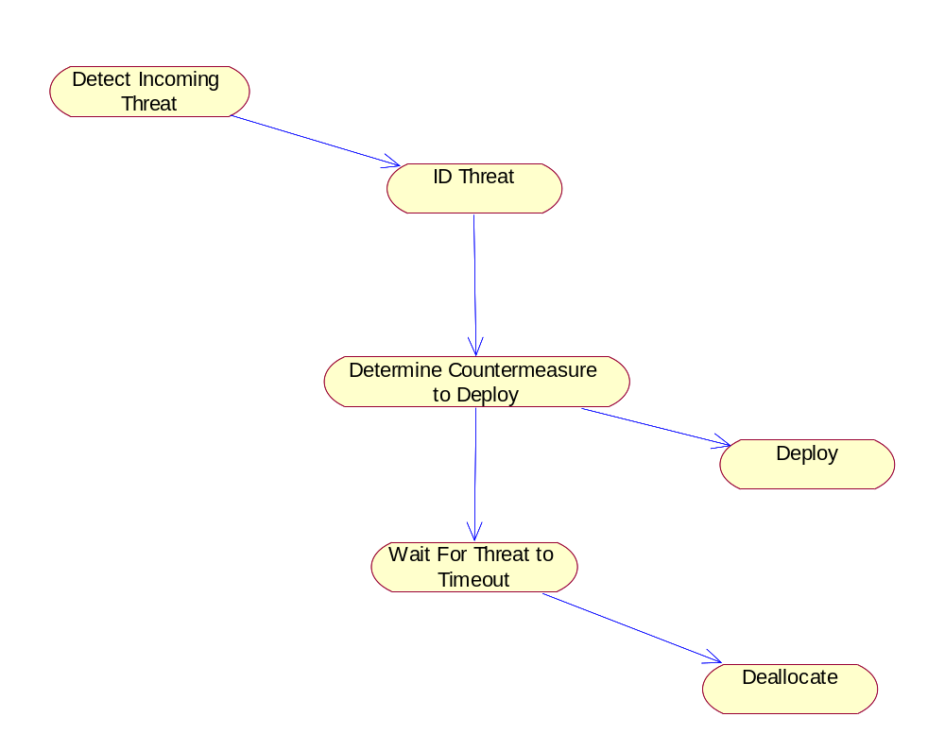
Sensor
SACC
CM
Figure 2 - SACC Main Processing

2. Requirements

2.1 System Initialization
During system startup, the SACC shall read in expected threat wave forms and associated jam-codes from the NVSU [SACC-SSS-0001]. The SACC shall be capable of reading in the initialization data in CSV, XML, and binary formats [SACC-SSS-0002].

During system startup, the SACC shall establish a TCP socket connection with the MC/CM system [SACC-SSS-0004].

During system startup, the SACC shall establish a TCP socket connection with the sensor [SACC-SSS-0005].

During system startup, the SACC shall establish a TCP socket connection with the INU [SACC-SSS-0013].

2.2 Situational Awareness
At any time the SACC shall accept threat wave-form and jam code data from the MC [SACC-SSS-0006].

The SACC shall receive threat data from the sensor [SACC-SSS-0007].

The SACC shall compare wave forms received from the sensor to wave forms read from the NVSU or received from the MC in an attempt to identify the threat [SACC-SSS-0008]. Any threat wave form that can not be identified shall be reported by the SACC to the MC as an unknown threat [SACC-SSS-0009].

When a threat has timed out (it’s time to go has reached 0), the SACC shall deallocate any CM that was allocated to the threat [SACC-SSS-0012].

2.3 Countermeasure Control
For all identified threats, the SACC shall deploy the CM, if available [SACC-SSS-0010].

When deploying a CM, the SACC shall specify the jam code to use based on the threat type [SACC-SSS-0011].

If the required CM is already deployed for a threat, the SACC shall report the uncountered threat to the MC [SACC-SSS-0014].

The SACC shall update the pointing position of the CM so that CM’s bore sight remains with 1 degree of the angle of arrival (AOA) of the incoming threat [SACC-SSS-0003].

2.4 General Requirements
The SACC software shall run on an x86 architecture based computer running Windows XP [SACC-SSS-0015].

The SACC software shall be implemented in C++ [SACC-SSS-0016].

4. Notes

4.1 Acronyms
AOA Angle of Arrival
CM Countermeasure
HAP Hit Avoidance Protection System
INU Inertial Navigation Unit
MC Mission Computer
NVSU Non-Volatile Store Unit
SACC Situation Awareness/Countermeasure Controller

